User & Permissions Management - Processes & Jobs - Processes

whoami – Display current user.
id – identifies your login name and group and any supplementary group you belong to.
sudo – short for “superuser do”, execute commands with root privileges.
passwd – Change user password. It is important to regularly change passwords as a fundamental practice in maintaining secure systems.
chmod – Modify file permissions of a file or directory .

This is crucial for securing files and directories by controlling who can read, write, or execute them. For example, chmod 700 filename would give the owner read, write, and execute permissions, while all other users would have no permissions
chown – Change file ownership of files and directories.
To use chown, you must be the owner of the file. Only root can use chown to change ownership. Ordinary users cannot give their files to someone else. Using chgrp, ordinary users can change the group ownership of a file if they own the file and they are a member of the target group.
This is another important tool for securing file and directory access. For example, chown user:group filename would change the ownership of the file to the specified user and group.
usermod
The usermod command allows an administrator to modify a user account. This can include adding the user to a new group (which may have certain permissions), changing the user’s home directory, or even changing the username.
find
While not specifically a security command, find is a powerful tool for locating files and directories. It can be used in conjunction with other commands to search for files with specific permissions or ownership.
last
The last command shows the last logins on the system. This can sometimes help to detect any unusual login activity.
history
The history command displays the command history of the current user. It’s beneficial for auditing purposes, allowing you to see what commands have been run previously.

Process and System Monitoring
- ps aux – List running processes.
- top – Display real-time system processes.
- kill – Terminate a process.
- df -h – Show disk space usage.
- uptime – Display system uptime.
Networking Commands
- ifconfig / ip a – View and configure network interfaces.
- netstat -tulnp – Display active connections and listening ports (ss also used for same purpose).
- nmap – Scan networks for open ports.
- ping – Check network connectivity.
- tcpdump – Capture and analyse network traffic.

Permissions & Users

Commands: chmod, chown, umask, whoami, id, groups
Exercise: Create a file and make it readable only by the owner; check with ls -l.
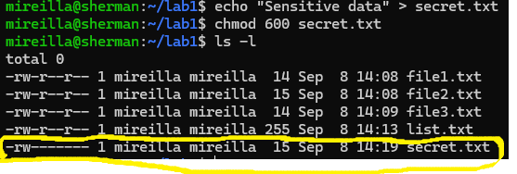
Run whoami, id, and groups to check your current user and group.

Question: How do permissions prevent data leaks?
Linux file permissions control who can read, write, or execute files. Permissions act as a first layer of defence, stopping unauthorised access to sensitive logs, credentials, or configuration files.

Processes & Jobs

Commands: ps, top, kill, jobs, fg, bg
Start a program that runs for a while. In this example, the program will run for 100 seconds. The job is run in the background.
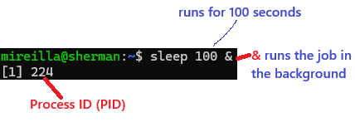
Use jobs to see the background job.
Use ps aux | grep sleep to find the PID of the process.
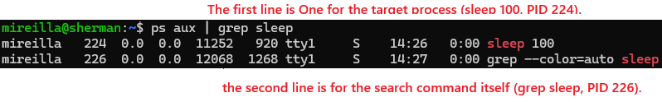
Kill the process:
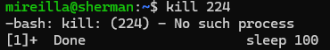

Question: Can you think of a reason why the output shows there is no process to kill?

Question: How might malware hide as a process?
Malware often runs as a background process, disguising itself to avoid detection. Detecting malware often means auditing running processes for anomalies (strange names, unusual paths, odd parent/child relationships)
- It may use a legitimate-sounding name (ssh, cron, kworker) so it blends into normal system activity.
- It may run with low CPU usage so it doesn’t stand out in top or ps.
- Advanced malware may even unlink itself from process listings, though most beginner-level malware just relies on looking “normal.”

Useful Utilities

Tools: tar, gzip, strings, file, hexdump
Create a new folder project with sample files.
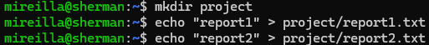
Compress the folder into project.tar.gz.
Extract it into a new directory unpack.
Create a mock binary file for analysis.
Use file binaryfile to identify what kind of file it is.
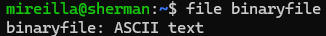
Run strings binaryfile to extract printable text (e.g., "secretpassword").
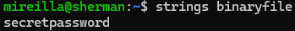
Run hexdump -C binaryfile to see the raw hexadecimal contents.
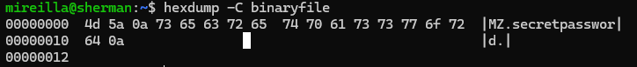

Question: How could strings and hexdump help detect malware?
These tools reveal what is hidden inside binary files. Using both together helps analysts reverse-engineer malware samples, spotting hidden instructions or data that normal text editors can’t show.
Strings extracts printable text (like hardcoded IPs, URLs, or passwords).
- Example: A suspicious binary might contain http://malicious.example.com or secret_key=....
hexdump shows the raw binary data in hex + ASCII side by side.
- Useful to see magic numbers (file signatures) or non-printable payloads.

